**Site Plan**

**Site Name**

Bountiful Fruits

**Site Purpose**

To encourage customers to buy fruit and to create their own fruit drink. Also, let customers know here to find a food truck and the weather in the area.

**Target Audience**

Those in the western California area that have an interest in eating healthy, organic locally produced fruit and enjoy alternative ways of consuming their fruit. Also, those on a juice diet or enjoy fruit drinks.

**Site Map**

Homepage

About Us

Fresh

**Typography**

|  |  |  |  |
| --- | --- | --- | --- |
| Site Header | Congenial Black | 40px | Sample |
| Primary Navigation | Britannic Bold | 35px | Sample |
| Footer Navigation | Britannic Bold | 30px | Sample |
| Heading 1 | Congenial Semi Bold | 30px | Sample |
| Heading 2 | Congenial Semi Bold | 25px | Sample |
| Heading 3 | Congenial Semi Bold | 25px | Sample |
| Paragraph Text | Congenial Light | 16px | Sample |

**Color Scheme**

|  |  |  |  |
| --- | --- | --- | --- |
| Site Header | Congenial Black | 40px | Sample |
| Primary Navigation | Britannic Bold | 35px | Sample |
| Footer Navigation | Britannic Bold | 30px | Sample |
| Heading 1 | Congenial Semi Bold | 30px | Sample |
| Heading 2 | Congenial Semi Bold | 25px | Sample |
| Heading 3 | Congenial Semi Bold | 25px | Sample |
| Paragraph Text | Congenial Light | 16px | Sample |

**Wireframe Sketches**

**Homepage**

**Phone**

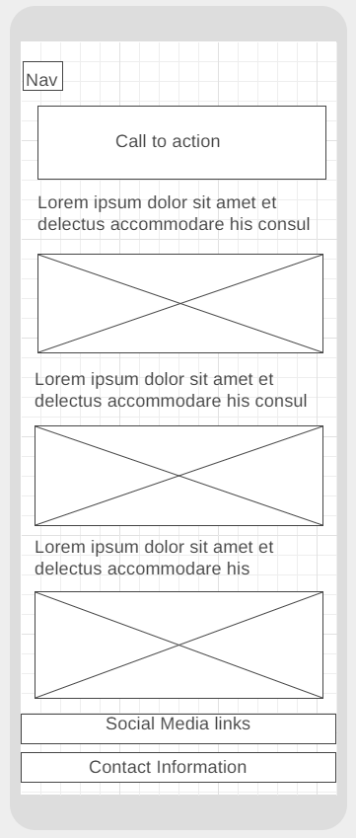

**Tablet**

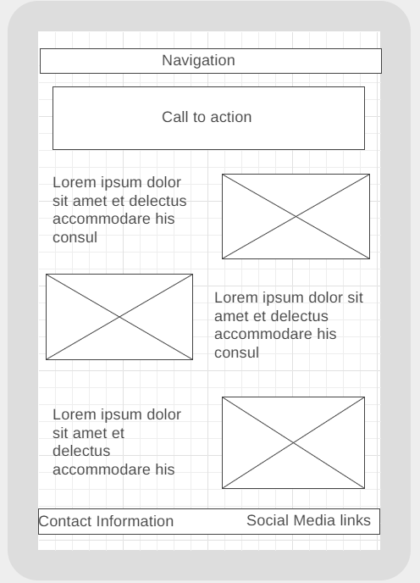

**Desktop**

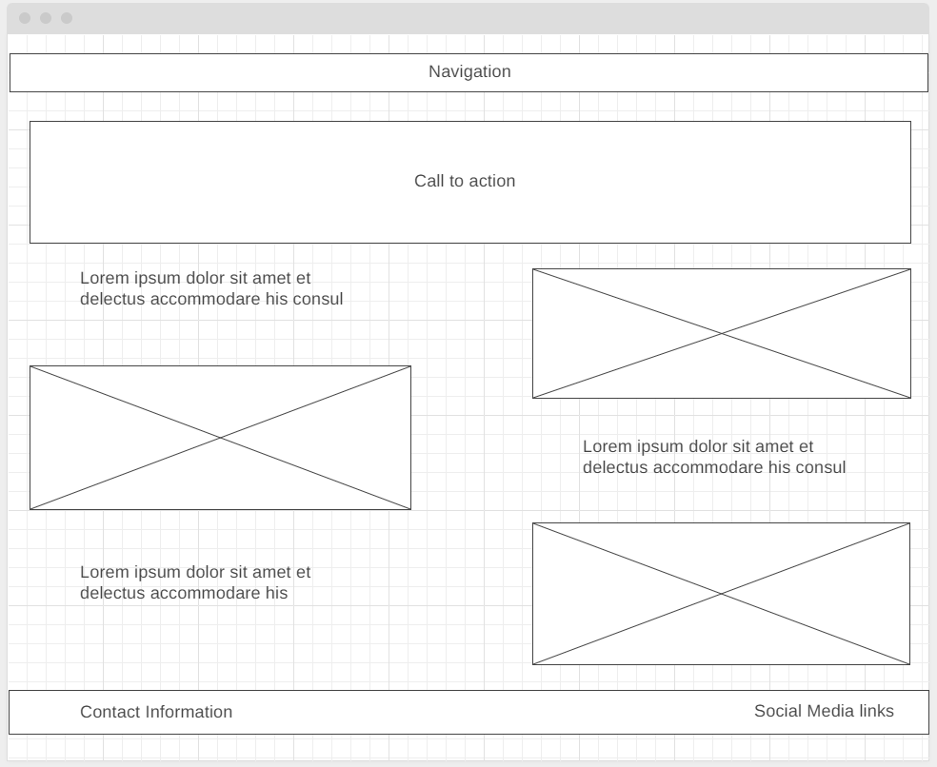

**Fresh**

**Phone**

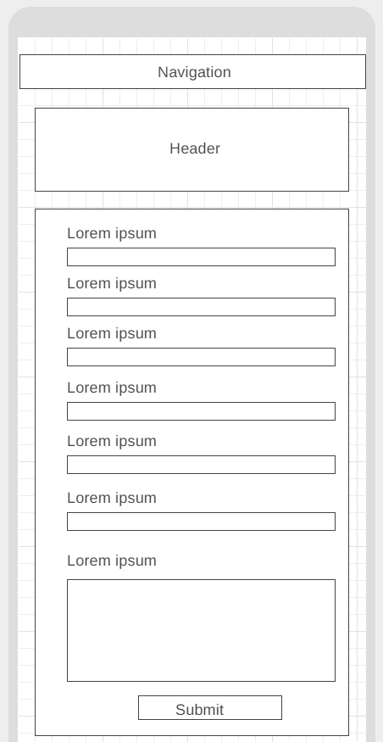

**Tablet**

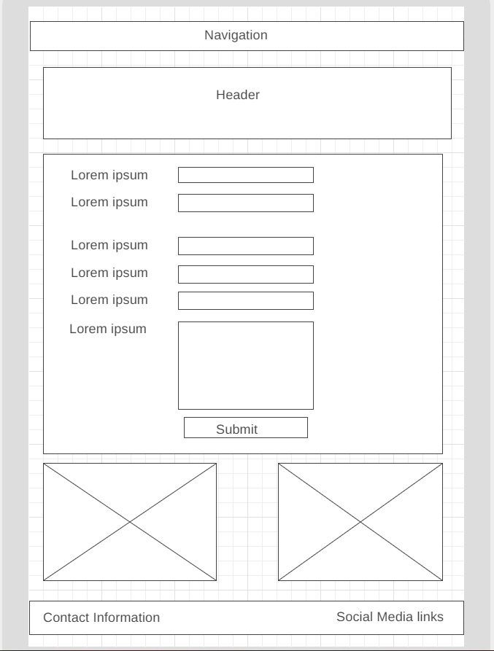

**Desktop**

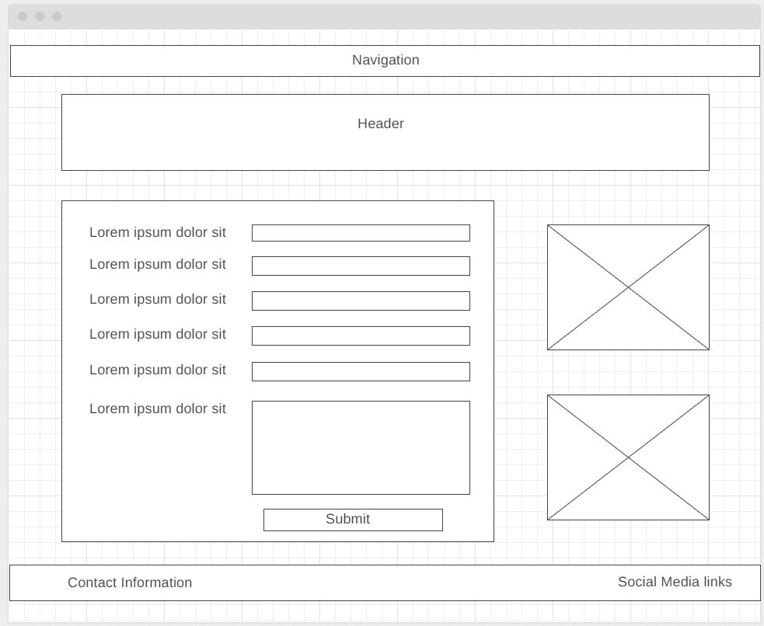

**About Us**

**Phone**

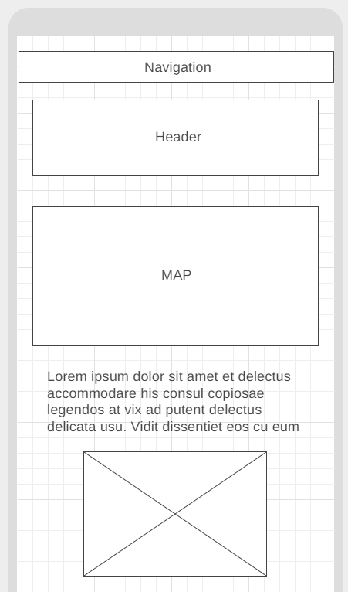

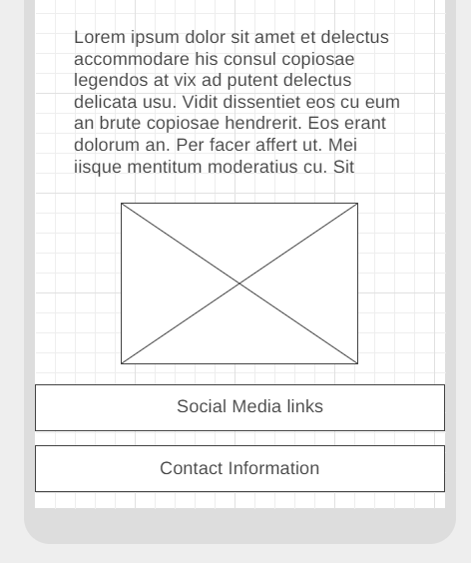

**Tablet**

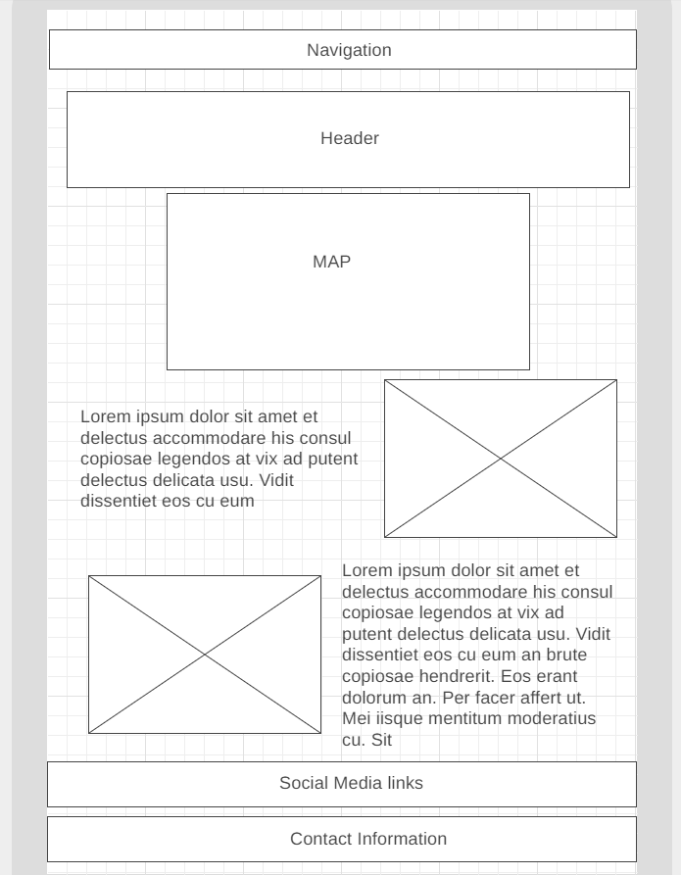

**Desktop**

